Pokhara University

Level: Bachelor | Semester – Spring | Year : 2009
Programme: BE |  | Full Marks: 100
Course: Electronic Circuits |  | Pass Marks: 45
 |  | Time : 3hrs.

Candidates are required to give their answers in their own words as far as practicable.
The figures in the margin indicate full marks.

Attempt all the questions.

 | - Derive the expression of the total voltage gain of n-stages cascading of the transistors. Why CE configuration is used in intermediate stages while cascading? Give reasons.  - Using re model, find VL/VS for the cascaded BJT amplifier given below. Assume re₁ = re₂ = 20 Ω , β₁= β₂= 100  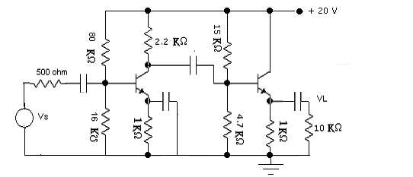 | 8  7
 | - Explain the effect of coupling and Bypass capacitor on frequency response. Explain why cutoff frequencies are also called 3db frequencies.  - Draw circuit diagram for complementary symmetry push-pull class B amplifier. Explain its working principle. What is cross over distortion? | 8  7
 | - With necessary derivation verify that "though the negative feedback reduces the gain, it improves gain stability and frequency response".  - State Barkhausen criterion for oscillation. Explain wein Bridge oscillator with circuit diagram. Derive the expression for the frequency of the oscillator. | 8  7
 | - What are the main characteristics of an ideal operational amplifier? Draw suitable integrator circuit and derive its output voltage.  - Draw the circuit diagram of a pulse generator implementing OP-AMP and explain its operation. Draw necessary waveforms. | 8  7
 | - Draw the circuit of a logarithmic amplifier and deduce for the output voltage. How can you compensate its temperature effects?  - What are the main reasons of A to D and D to A conversion? Explain the operation of Flash type A to D conversion. | 8  7
 | - What is regulated power supply? Explain the operation of a transistor shunt regulator.  - Draw R-2R ladder circuit for D to A conversion and explain its operation. | 8  7
 | Write short notes on: (Any Two)  - Voltage Controlled Oscillator  - Emitter Follower  - Application of Instrumentation Amplifier | 2×5

